**Practical 7-B**

**PRN:2018BTECS00045**

**Git repo:** [**https://github.com/Apurva0707/PL3_lab_2018btecs00045**](https://github.com/Apurva0707/PL3_lab_2018btecs00045)

**To design and develop web pages using HTML Multimedia elements.**

Problem Statement 1:

Design a HTML web page that contain audio players. Access it locally and in LAN using a web server.

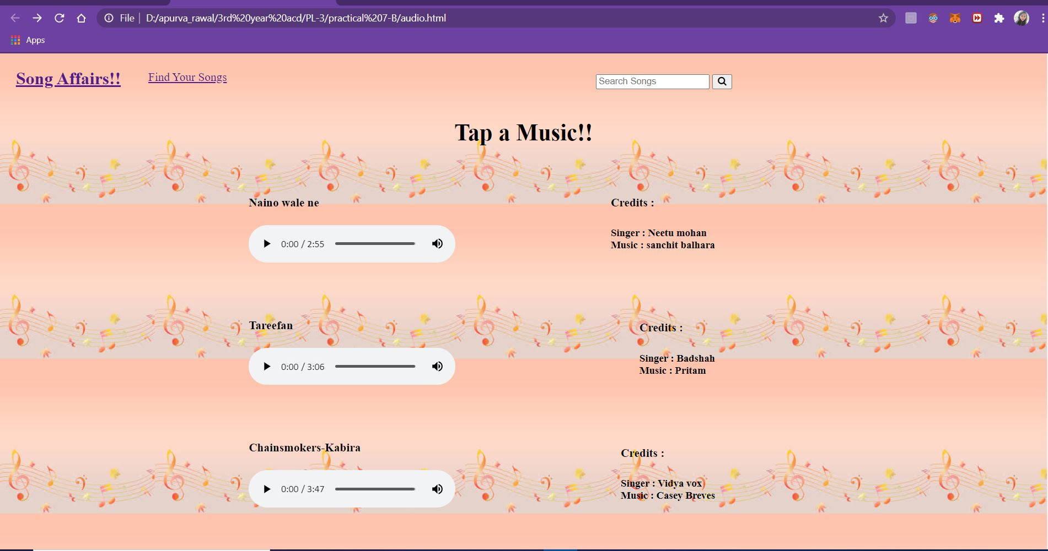

Problem Statement 2:

Design a HTML web page that contain video players. Access it locally and in LAN using a web server.

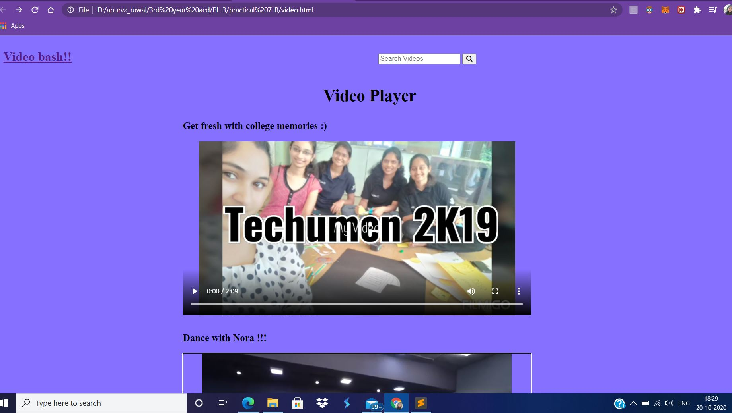

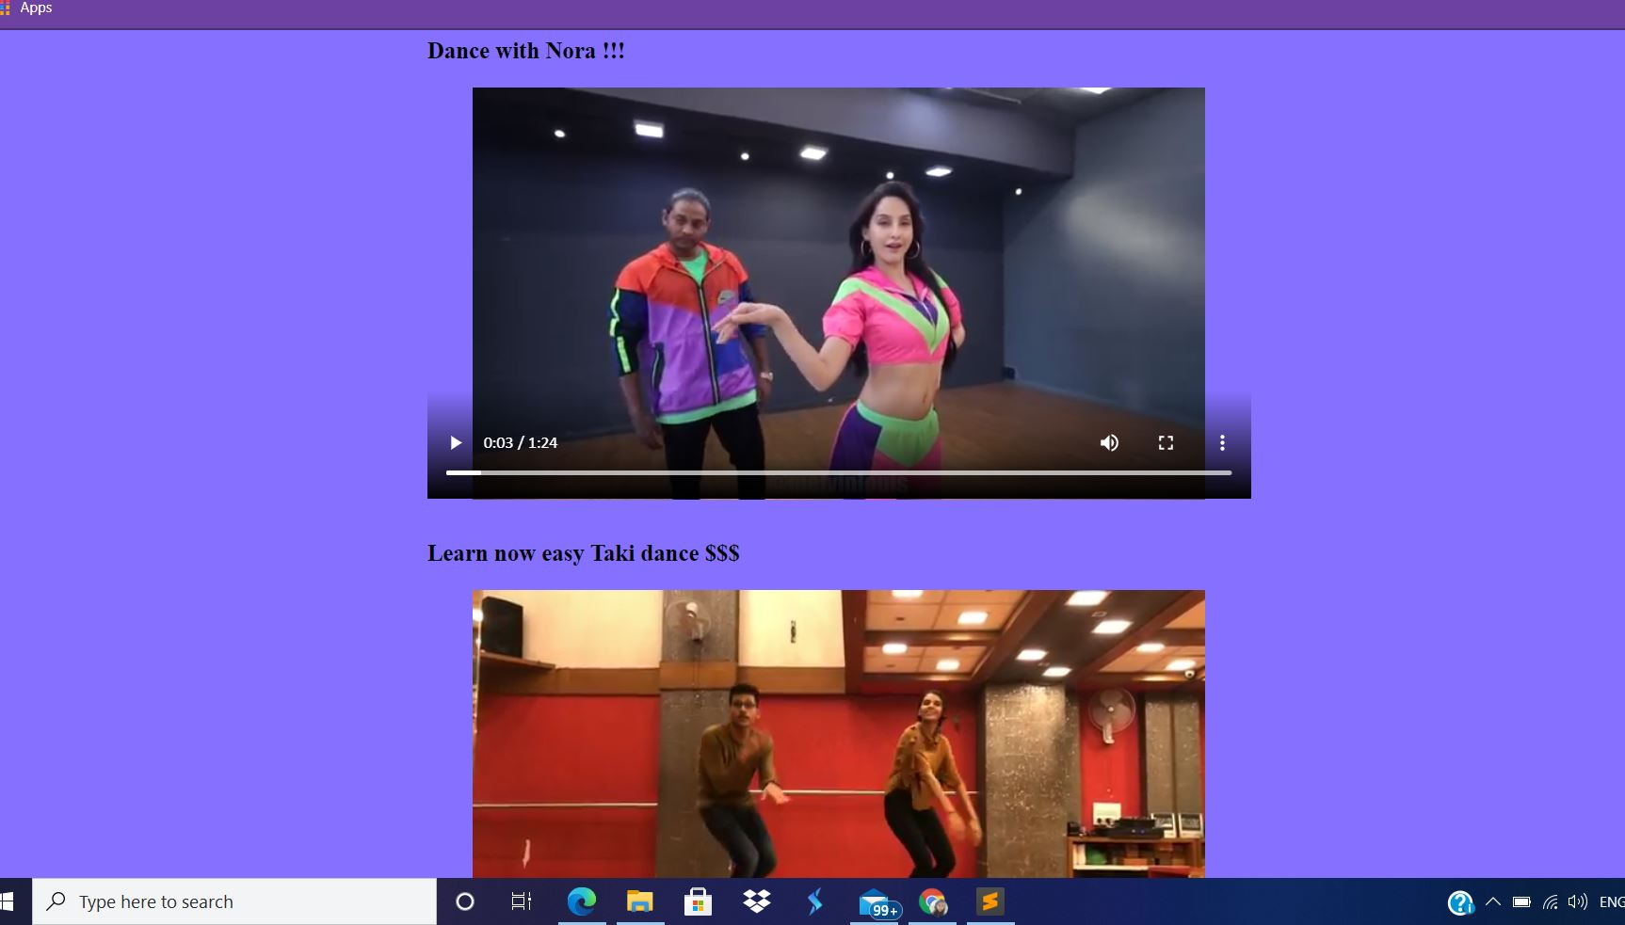

Problem Statement 3:

Design a HTML web page that contain YouTube videos. Access it locally and in LAN using a web server.

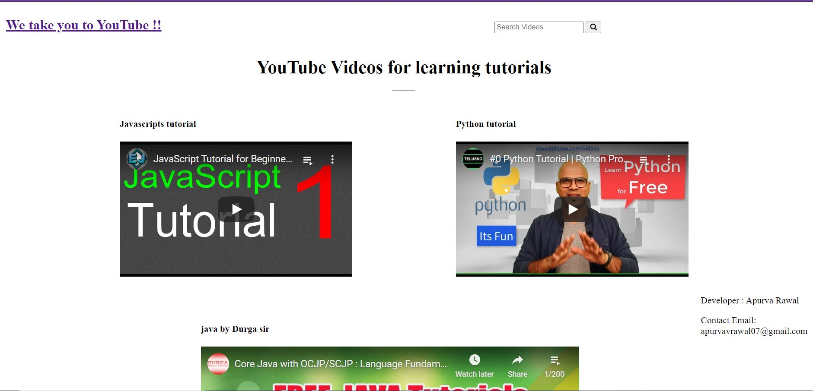

Problem Statement 4:

Design a HTML web page that has external resources embedded. Access it locally and in LAN using a web server.

